Lesson Plan for Children’s Book: “Why Is Earth Sick?”
Grades K-2

Lesson on Climate change and Greenhouse Gases:
Video:
- Short Film: Ozzy Ozone https://www.youtube.com/watch?v=WKrPd-8CJBM or https://www.youtube.com/watch?v=VM-nHE_oGFU
Visuals/PowerPoint:
- “The story of the mean greenhouse gases” – power point/animations and quiz
Online learning game:
- Greenhouse Gas Attack (good to play right after PowerPoint): https://spaceplace.nasa.gov/greenhouse-gas-attack/en/#/review/greenhouse-gas-attack/game.swf
- NASA Climate Kids – Coral Bleaching https://climatekids.nasa.gov/coral-bleaching/

Activity:
- Map with Velcro stickers or just regular stickers where can show environmental disasters and learn what is going on in different places of the world – Print out stickers at the end of this packet
- Energy Game file:///C:/Users/Jaidacyn/Downloads/Activitybook_web.pdf
Melting Ice and Sea Level Rise Experiments:
- Ice melt on different color surfaces:
https://www.need.org/Files/curriculum/sciencefair/ColorsAndHeat.pdf
- Sea Level Rise experiment - https://www.jpl.nasa.gov/edu/learn/project/how-melting-ice-causes-sea-level-rise/
Climate Change Talking Points:
- https://docs.wixstatic.com/ugd/3687d6_6a513846e5954c238ccaadbf5694d77e.pdf

Helpful diagrams:
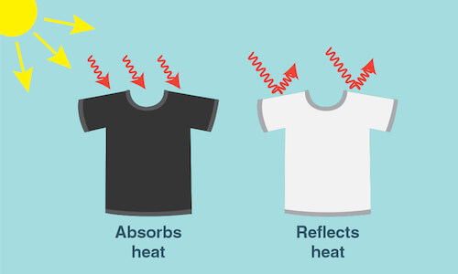
Credit: NASA/JPL-Caltech
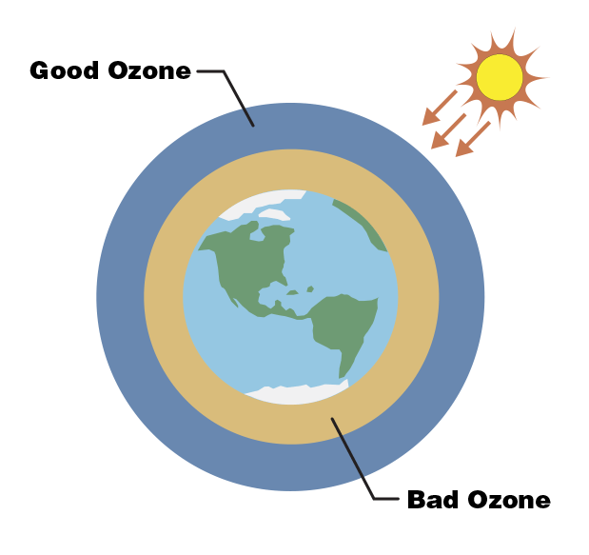
Credit: NASA/JPL-Caltech
https://climatekids.nasa.gov/air-pollution/

Lesson on Water Scarcity:
Worksheets:
- Water Usage coloring book pdf - https://thewaterproject.org/resources/elementary-school-lesson-plans/coloring2016.pdf

Lesson on Plants:
Activities:
- Start a garden at the school and take 10 minutes each day for kids to water plants.
- Make seed paper (recycled paper) https://climatekids.nasa.gov/seed-paper/
- Terrarium https://climatekids.nasa.gov/mini-garden/ or succulents in a half cut plastic water bottle
- Activity Guide: https://kids.nationalgeographic.com/content/dam/kids/photos/other/books/worksheets/elementary/ngreaders_sheet_l1_cm2020_f.pdf
Experiments:
- Plants and sunlight experiment:
https://www.need.org/Files/curriculum/sciencefair/EnergyforLife.pdf
- Sprouts need sunlight experiment:

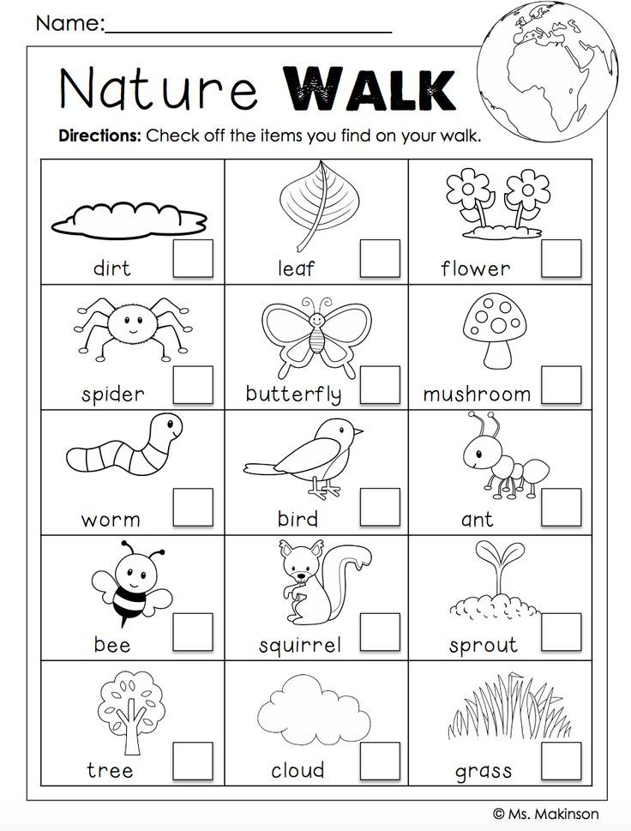

Lesson on Plastics in the Ocean:
Videos:
- Plastic videos https://kids.nationalgeographic.com/explore/nature/kids-vs-plastic/
Visuals/Powerpoint:
- PowerPoint “this vs. that”
- Slide show of animals being effected by plastic - https://kids.nationalgeographic.com/explore/nature/kids-vs-plastic/
Activity:
- Recycled Bird Feeders- Have students bring a recycled bottle, old shoe, half of an orange peel, plastic milk tank, carton of milk or juice, plastic lemon net, or make a pine cone bird feeder (peanut butter and bird seed) https://www.lifegate.com/bird-feeders-recycled-materials
- Make lunch bag https://kids.nationalgeographic.com/explore/nature/kids-vs-plastic/lunch-bag/
- Make a cutlery holder https://kids.nationalgeographic.com/explore/nature/kids-vs-plastic/cutlery-holder/
- Make paper straws https://kids.nationalgeographic.com/explore/nature/kids-vs-plastic/paper-straws/
Worksheets:
- Make “this not that worksheet” – see “This Not That” PowerPoint for ideas!
Pledge:
Take Plastic pledge https://kids.nationalgeographic.com/explore/nature/kids-vs-plastic/

Lesson on Recycling:
Activity:
- Repurpose for a purpose (make handbags) Bring your own t-shirt -https://climatekids.nasa.gov/tshirt-bag/
- Recycled half water bottle with succulent plant
Online learning games:
- Recycle this virtual game – https://climatekids.nasa.gov/recycle-this/
- Recycle Roundup Game – https://kids.nationalgeographic.com/games/action-and-adventure/recycle-roundup-new/

Experiment:
- Recycled or New Paper experiments: https://www.need.org/Files/curriculum/sciencefair/RecycledorNewPaper.pdf
Worksheets:
- Recycle Maze pdf. – The Water Project https://thewaterproject.org/resources/elementary-school-lesson-plans/Recycling_Maze.pdf
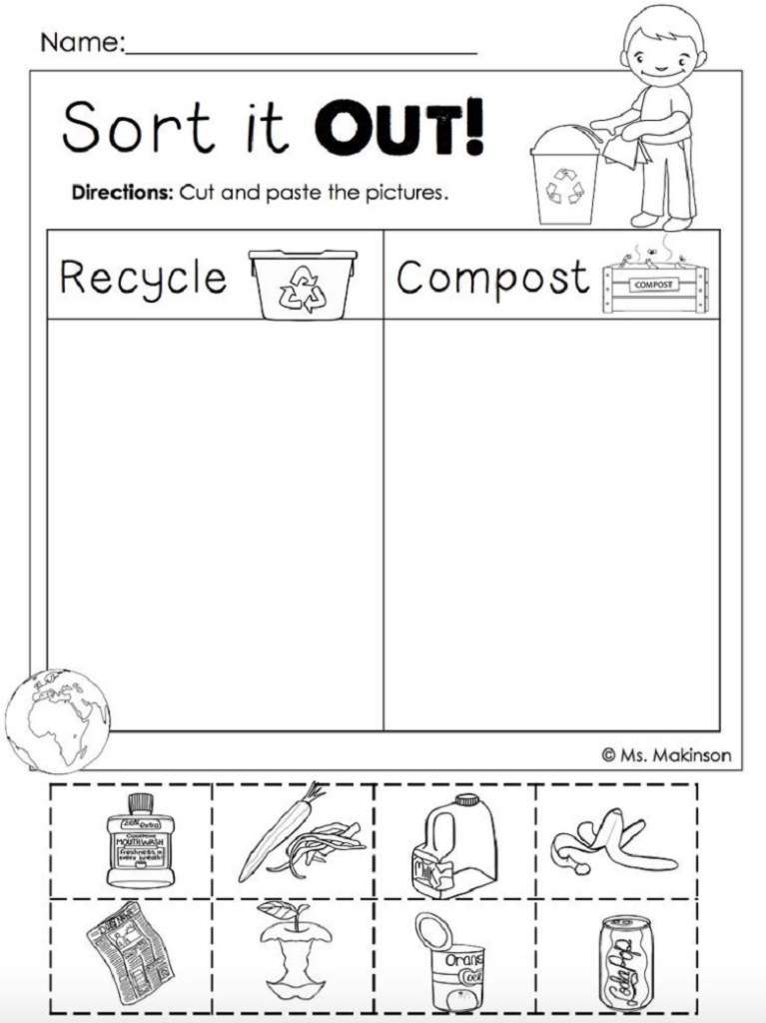
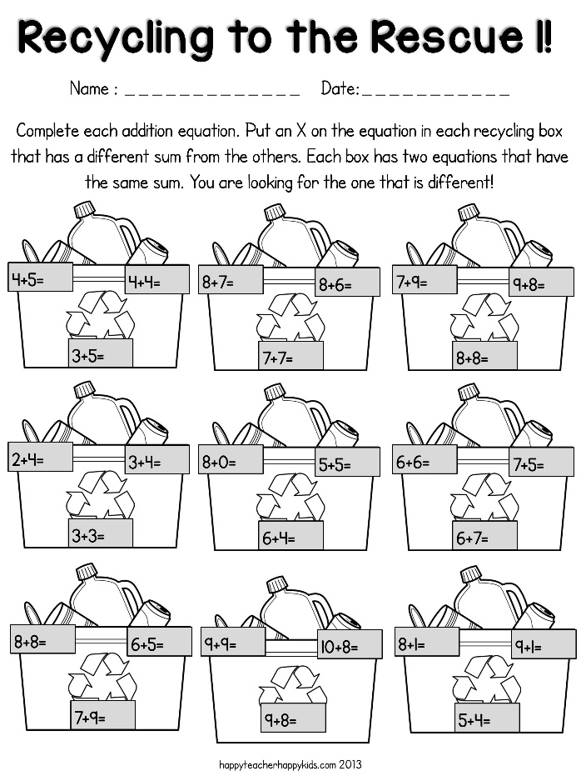
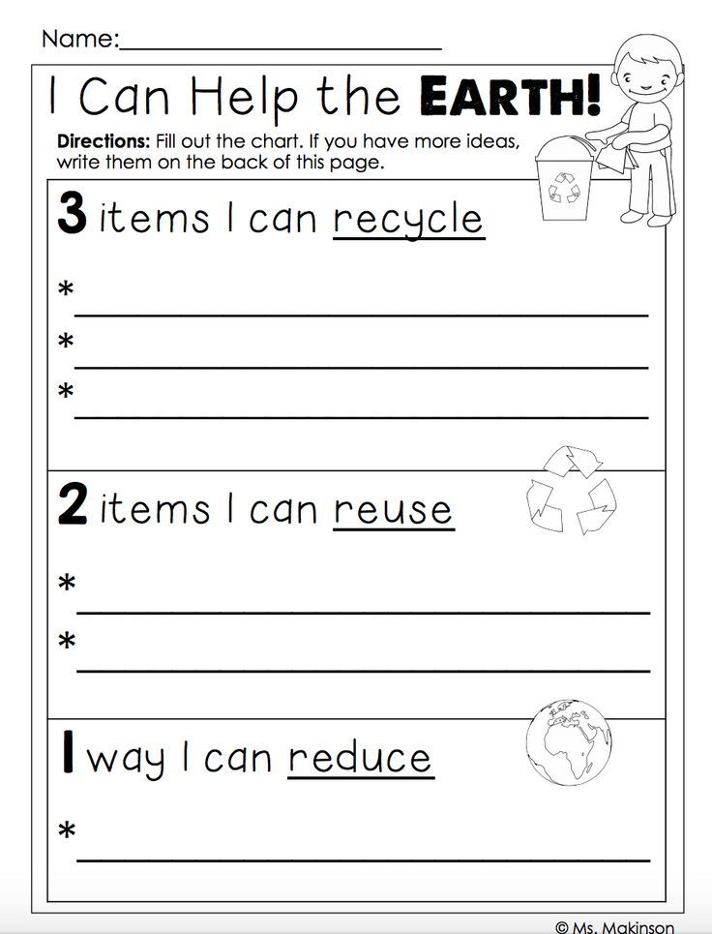

Extra Earth Day celebration ideas:
Pledge Board
- Have every kid trace and cut out their footprint and how they will reduce their environmental footprint (i.e. eat meat less, carpool, walk/ride bike more etc.) – If you would rather have pre-done footprints please see the footprint image at the end of this packet
Activity:
- Draw earth on paper plate or on news paper and write how you will help the earth. – can hang them up in the classroom
- “Thank you Earth” – love letters to earth! Have kids write down why they are thankful for our earth!
- Earth Day online quiz https://kids.nationalgeographic.com/games/quizzes/earth-day-quiz-whiz/

Holiday activity – pumpkin globe:
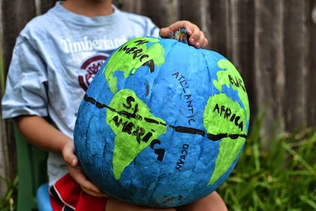

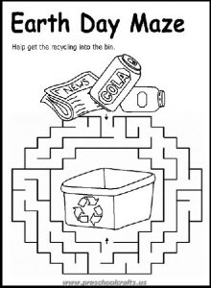
Earth Day Worksheets:

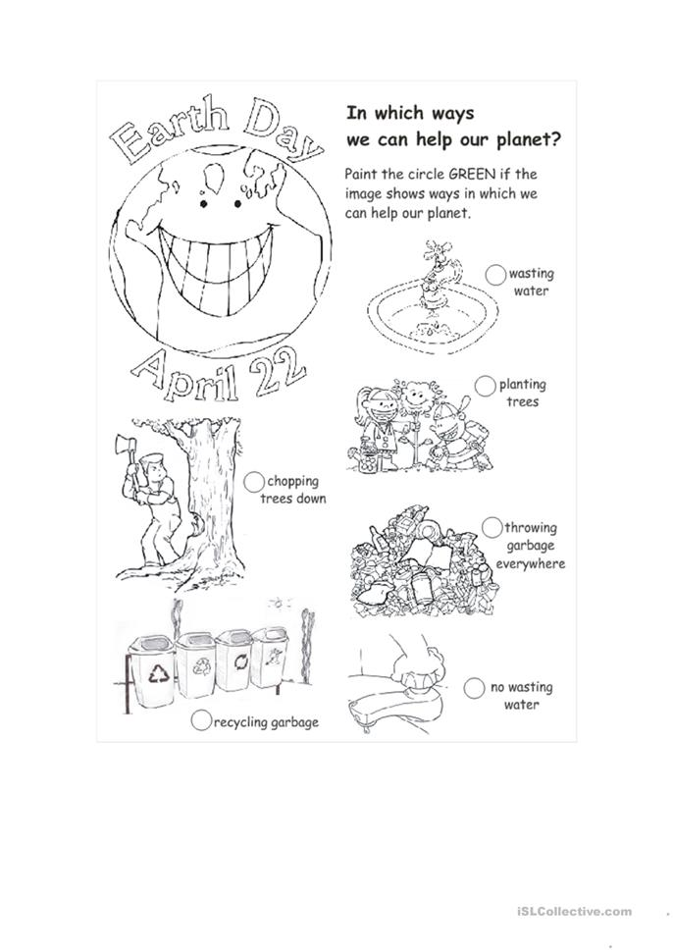
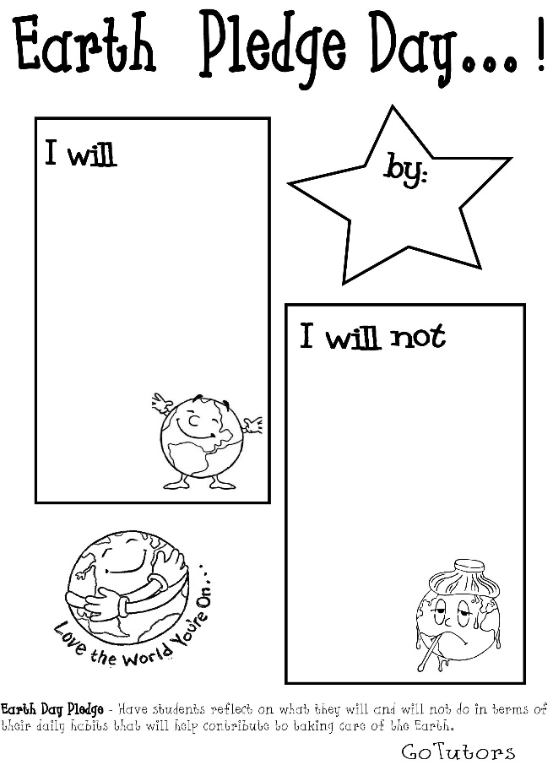
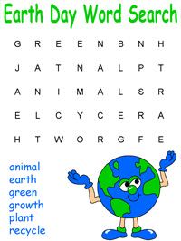

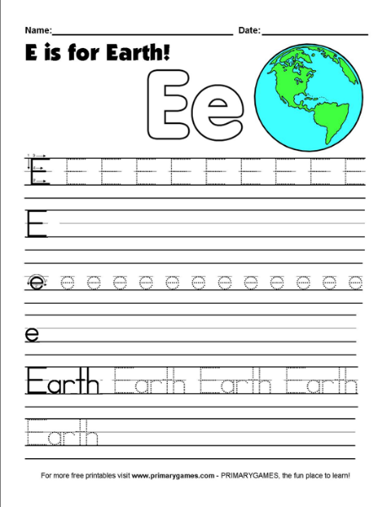
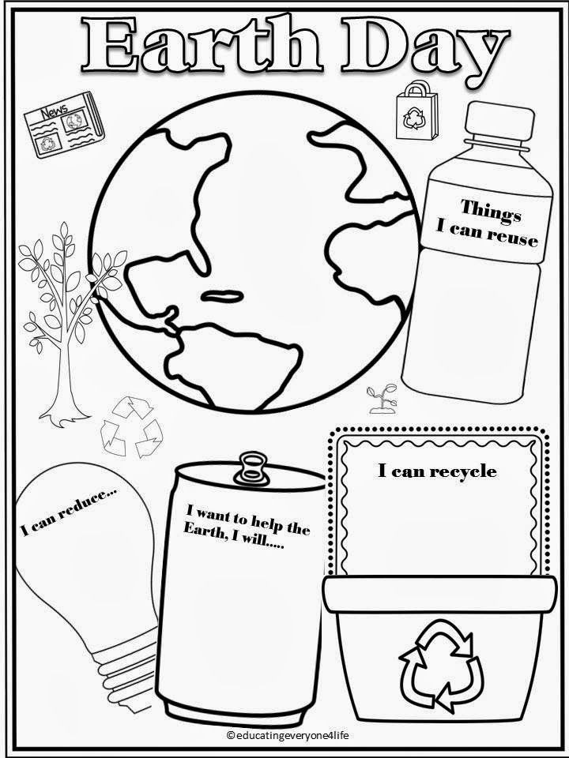
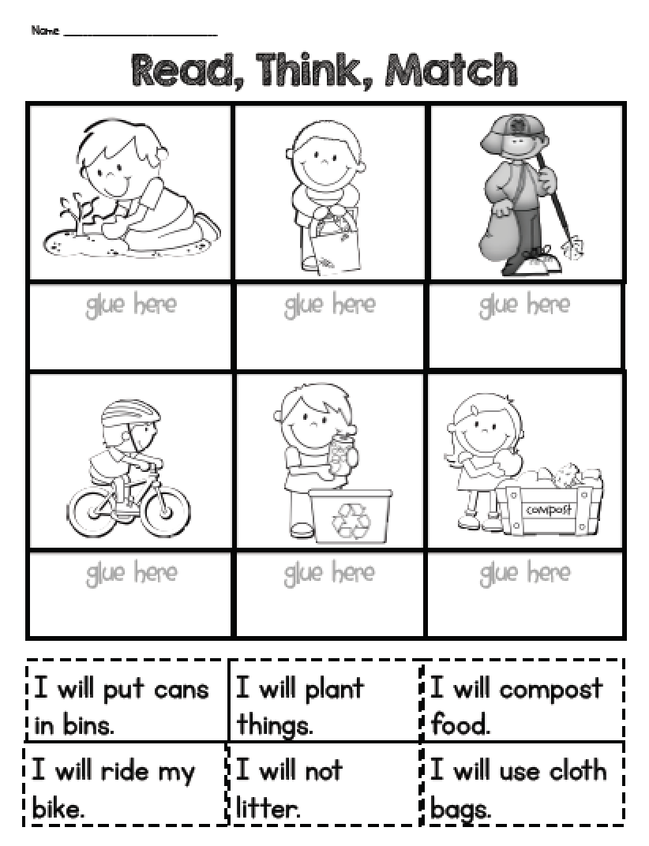
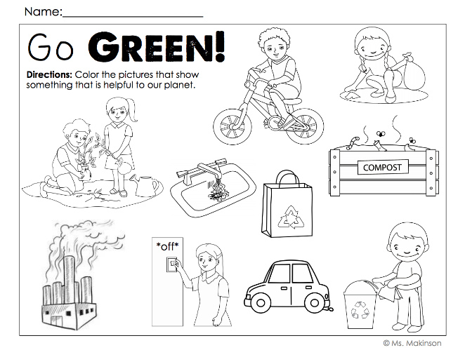

Video games https://climatekids.nasa.gov/menu/play/

Hang in Classroom:
Eco-friendly food guide “My Plate” https://www.teacherspayteachers.com/Product/Earth-Friendly-Food-Guide-5189240
10 ways to help nature https://8a582501-a5d3-495d-a9f8-406cc007e6f3.filesusr.com/ugd/3687d6_291040f2551e40deb45d5f036994f47e.pdf
10 ways kids can help earth https://docs.wixstatic.com/ugd/3687d6_ada68436e6894d8a8338397f8ca9f1a7.pdf
13 ways to save the earth https://www.climaterealityproject.org/sites/default/files/APR%2018%20NGK-Climate%20Change%20tips_0.pdf
Hang-ups on plastic:
https://kids.nationalgeographic.com/content/dam/kids/photos/articles/Nature/H-P/KidsVsPlastic/plastic-free-gifts.pdf
https://kids.nationalgeographic.com/content/dam/kids/photos/articles/Nature/H-P/KidsVsPlastic/plastic-free-party.pdf
https://kids.nationalgeographic.com/content/dam/kids/photos/articles/Nature/H-P/KidsVsPlastic/plastic-free-school.pdf
https://kids.nationalgeographic.com/content/dam/kids/photos/articles/Nature/H-P/KidsVsPlastic/plastic-free-snacks.pdf
https://kids.nationalgeographic.com/content/dam/kids/photos/articles/Nature/H-P/KidsVsPlastic/plastic_summer-fun_v8.pdf
https://kids.nationalgeographic.com/content/dam/kids/photos/articles/Nature/H-P/KidsVsPlastic/plastic-free-halloween.pdf
https://kids.nationalgeographic.com/content/dam/kids/photos/articles/Nature/H-P/KidsVsPlastic/plastic-free-restaurant-checklist.pdf

Other Info:
Why are veggies better than meat for the environment? https://www.petakids.com/save-animals/eating-animals-ruins-planet/

