Sustainable Fashion Show

Fashion show that will bring to light how detrimental the fast fashion industry is and how we as individuals can acquire a more sustainable wardrobe.

Runway Show themes:
- Nifty Thrifty – College students will make creative outfits for models of their choice (can be their friends/relatives/etc.) using only thrift store items. As the model is modeling clothing (over-head screen/ projector will show a diagram of what the designer/student used (before items) and how the designer creatively put the clothing pieces together.

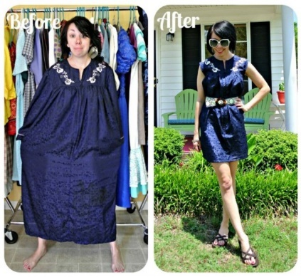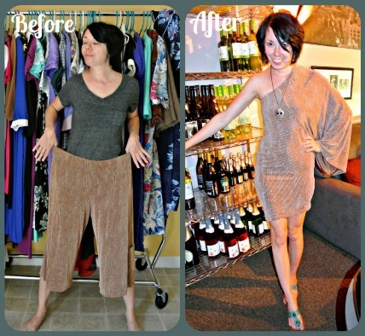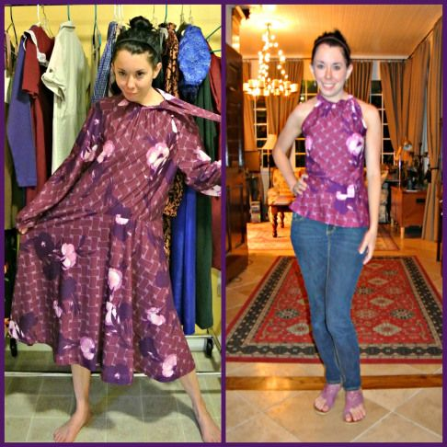
- Minimalist outfits – “All the ways you can wear… these {insert number} items” College students will make 3 clothing items into 5 different outfits (other criteria as far as accessories may be included). You could also show the different outfits off by trying to buy the same looking clothing and putting all of the outfits in a row on manikins to show all the different ways to use a few generic clothing items. This would be more of a display rather than a runway theme.

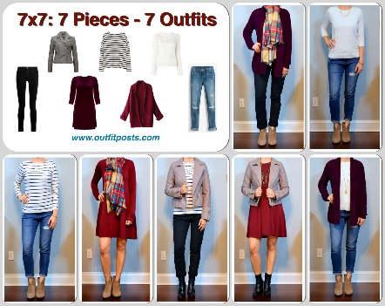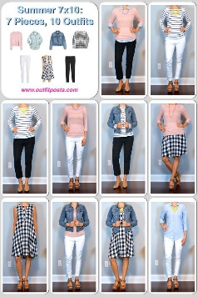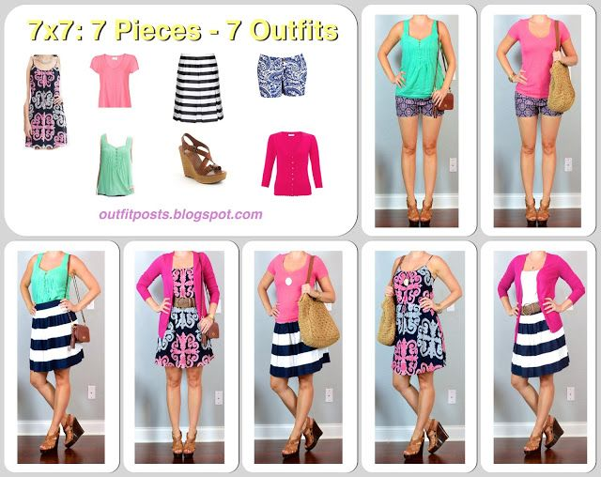
- Optional: Another runway idea is to make clothing out of everyday waste as a way of upcycling. The idea of this is to make the clothing only out of items that would be thrown in the recycling bin or trash can such as cardboard boxes, milk cartons, plastic bubble wrap, plastic bags, wrappers, plastic bottles etc. Competitors cannot go out and buy any of these items they have to be recycled.
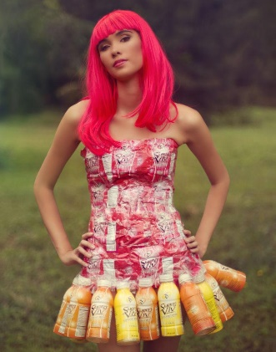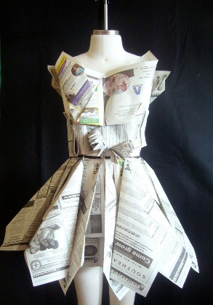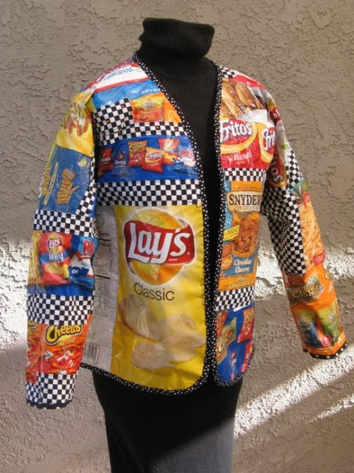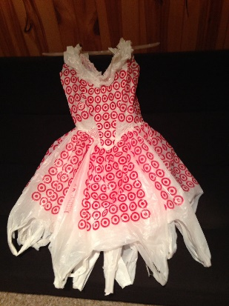

***Documentary showing: “The True Cost” & “Minimalism” (or pick the important parts of the movies to watch during the events to go along with the topics) & Bea Johnson (@zerowastehome)
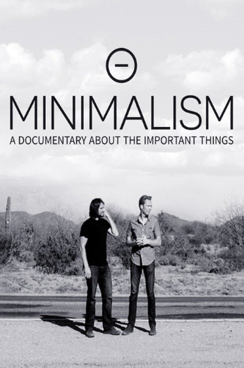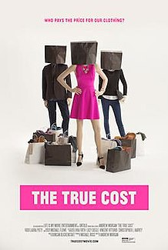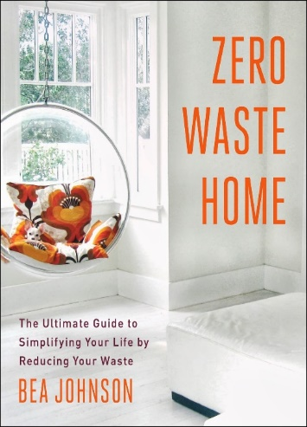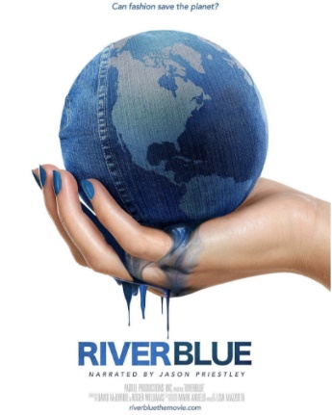
True Cost documentary website - https://truecostmovie.com/learn-more/environmental-impact/
The Minimalists documentary website - https://www.theminimalists.com/
River Blue documentary website - http://riverbluethemovie.eco/
Ted Talk w/ Bea Johnson - https://www.youtube.com/watch?v=CSUmo-40pqA

Workshops Intermission:

- Re-purpose for a purpose
- Show how to repurpose clothing -- handbags /headbands/ wash cloths etc.
- Bring your own T-shirt
- Bring old clothing to re-purpose (have old donated clothing to repurpose if people did not bring their own)

- Green In Jean
- Guest can bring their own Jean Jackets and put patches on them and decorate them to give them a “Second life”, while being educate on how specifically jean material is very harmful to our environment.

Advertise:
- College campuses
- Eventbrite
- Social media (Instagram, Facebook event page)
- Posters/flyers

Donation Zone/raising money:
People can bring clothes to donate to local charities /thrift stores
Raffle prizes (fair trade & sustainable products)

Additional Topics:
- Visual representation of facts on how many clothing items we throw away each year and the effect it has on the environment
- Leather Industry (Vegan leather)
- Cotton pesticides alternatives to cotton (organic cotton)
- Fair Trade (fair trade vendors or guest speaker)

To Do list for Sustainable Fashion Show:
- Contact Schools
- Ask for supplies
- Thrift Stores
- Joans (patches & bedazzler)
- Boutiques (minimalist outfits donation)
- Give a 5 minute talk to classes and sign up list
- Make & hang flyers
- Make sign up sheet
- Make cardboard diagrams (contact store with diagrams /more pictures?? – ask Char) (leather diagram)
- Put event on social media sites and advertise
- College campuses
- Eventbrite
- Social media (Instagram, Facebook event page)
- Posters/flyers
- Make world poster and footprint cutouts “How will you reduce your ecological footprints?”
- Make presentation for leather & cotton
- Put videos together from movie clips (most important parts)
- Put artist slideshow in order (showing picture of the designer and how they designed the clothing)
- Create playlist for fashion show & mingling
- Make Banner
- Contact photographer & videographer
- Measure distance of runway
- Print out resources to learn more?? – to have at the show
Contact:
- High Schools & college classes
- Contact fashion departments & tech/trade schools
- Contact people to lead workshops

Need from thrift stores:
- Jean Jackets
- Multiple of same outfit
- Large t-shirts
- Patterned clothing to use as patches/scrunchies/headbands
- Gift cards
- Clothing racks

Need:
- Projector
- Walkway (red carpet?)
- Clothing racks
- Microphone
- Changing area for models
Set-up:
- Chairs
- Tables
Food/drinks
- Vegan snacks
Criteria for sign-up sheet:
- Photo/headshot of artist (optional)
- Due date for submissions
- Email submissions via word attachment to ----- email----
- Pictures of before and after shots of outfit
- Social media information of artist (optional)
- Who will be modeling? You or a friend? If a friend, please list their full name here (you are responsible for your friend to show up the day of please provide your friends phone number/email here
- Are you interested in being a model for the minimalist segment? If yes, what is your size in pants/shirt
- Tell us a little about yourself and how you got into fashion
- What steps you did you take to achieve this look?
Decorations:
- String lights
- Succulents on tables
- Carpet/runway
- Optional: Earth angel wings painted on window/wall with “save the earth” “protect our earth” written over it
Additional:
- Auction off minimalist outfits (5 of each outfit) proceeds go to a charity!
- Raffle Prizes (fair trade & sustainable products & gift cards from thrift stores)
- Goody bags (optional)
- Donate clothing to local charity or thrift store
Possible social media hashtags or tag lines:
- Use and refuse
- Be seen, Be green
- Fair Fashion
- Runway the Greenway
- Don’t despair add some flare
- Despair behind the Wear
2 activities:
Repurpose for a Purpose:
- T-shirt tote Bags
- Scrunchies & headbands
- Have extra clothing from thrift stores people can use to make bags/headbands
- Get clothing racks (donated)
Be Green and wear Jean / Green in Jean
- Have guest bring their own Jean Jacket
- Buy Bedazzle and patches for jean jackets
- Buy extra jean jackets from the thrift store in case guest did not bring any

