Fright for Future
#frightforfuture
A night Full of Spooky and Gore, and were talking about AL Gore

Description: Bringing scary current issues such as climate change and animal rights to light this Halloween.

Food:
Vegan snacks
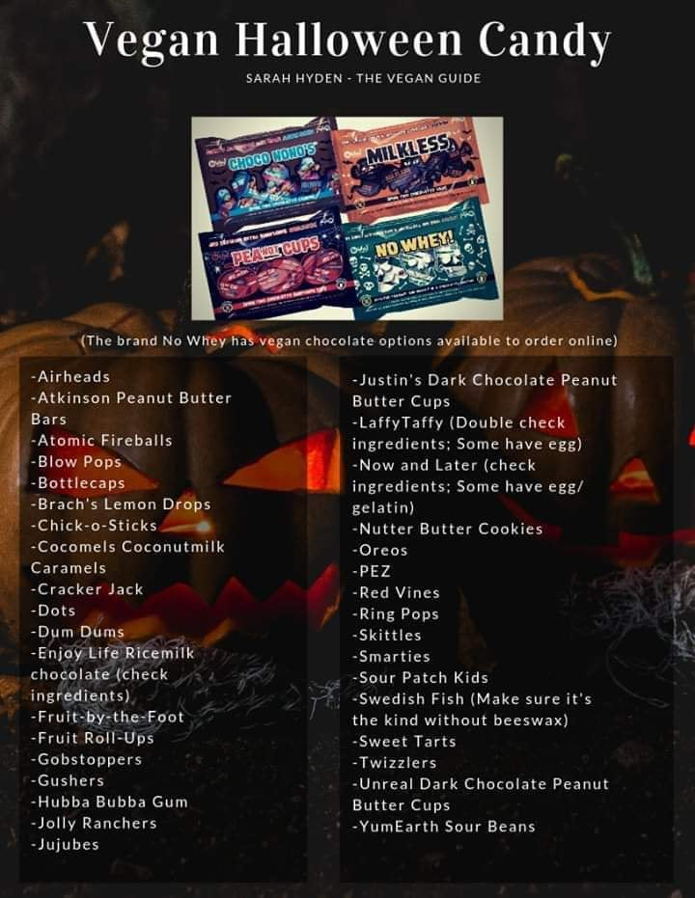
Vegan/ non-palm oil candy given out
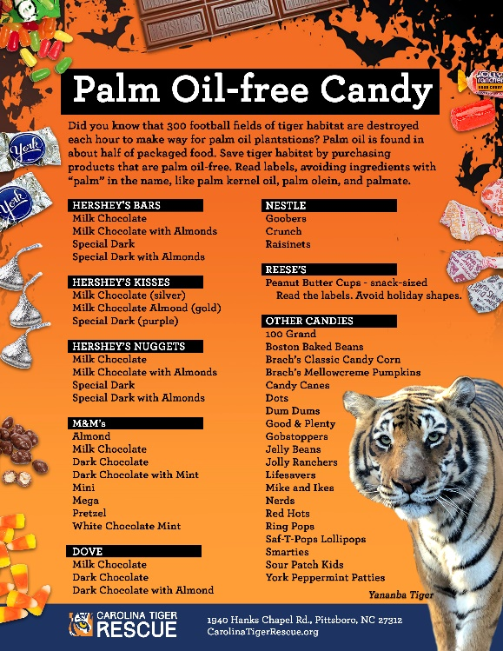

4 main Activities:
Vegan Cookie Decorating
This is an optional add on to the event. If you can make or buy a lot of vegan sugar cookies this can be a fun activity and it shows the importance of choosing a conscious way to eat!
Have a “Why Vegan?” information board to tell of all the reasons why eating vegan is better for our environment and animals!
Below are some links to great infographics that you can use for an information board on why to be vegan!
https://www.cowspiracy.com/infographic
https://www.mediapeta.com/peta/Images/Global/peta_infographic-truthabouteating.jpg
https://www.peta.org/features/vegan-diet-infographic/
https://onlybuyvegan.com/vegan-infographics/

Horror Short Films
(commentary on social issues/ films with meaning)
You can show the screening of the films at different times during the event, and do repeat showings of the films every hour or half hour.
Need: Projector/ white screen/ speakers
Horror Short Film “Take Off Your Clothes” (Fast Fashion)
https://www.youtube.com/watch?v=PyNGsYBD_7M
Horror Short Film “The Herd” (Animal Agriculture)
https://www.youtube.com/watch?v=IeyHBNodwOk&t=56s
Horror Short Film “The Herd” (Animal Agriculture)
https://www.youtube.com/watch?v=IOlEV9EtXvQ
Air pollution in India
https://www.youtube.com/watch?v=R6faJQ5F7s4
“Dream” (feat. Natalie Bergman, Ryan Merchant, Keenan O’Meara & Tal Altman)
https://www.youtube.com/watch?v=RjMzXykfbm8

Halloween “Cost”-ume Contest & Show
The “Cost” to “U” and “Me”
For this segment of the event it may be easier to have a team of volunteers design costumes and volunteers model the costumes the day of the event.
- Blood on Fur
- Leather/ Cow hide
Picture examples below:
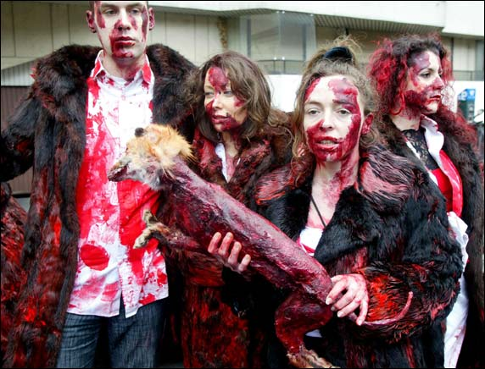
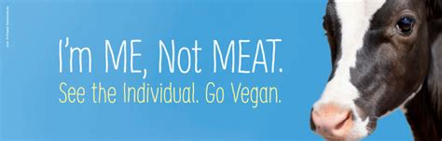

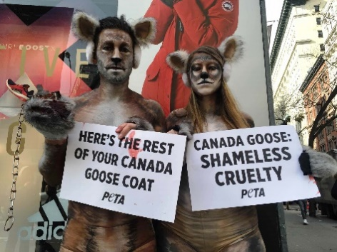
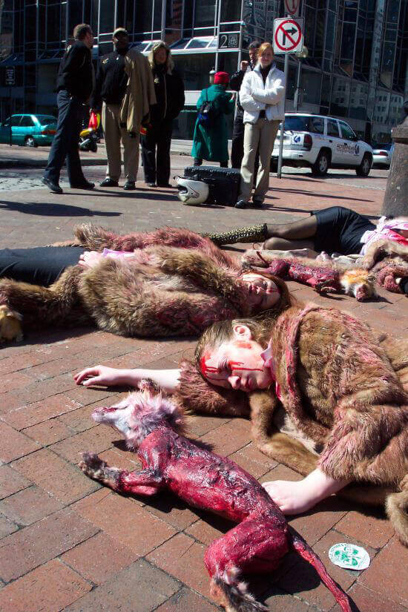
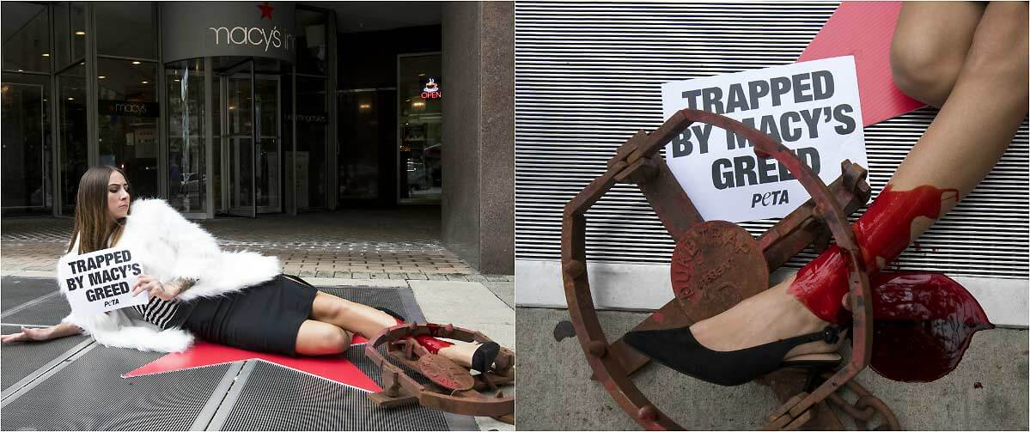

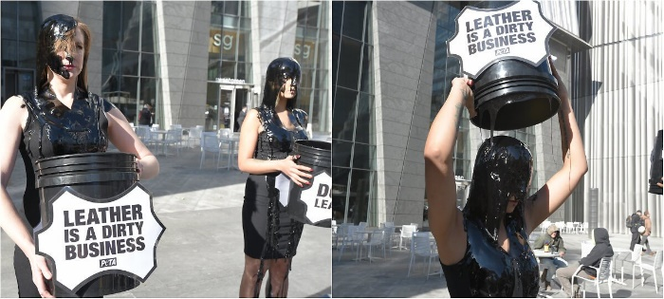
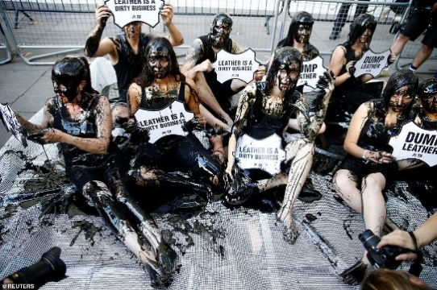
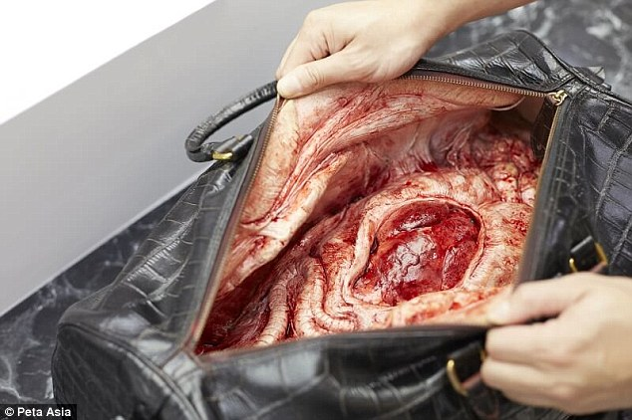
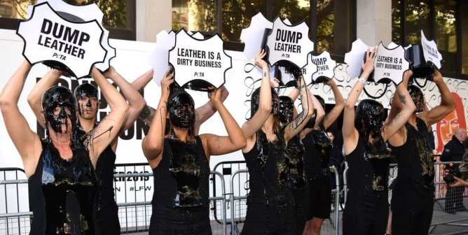
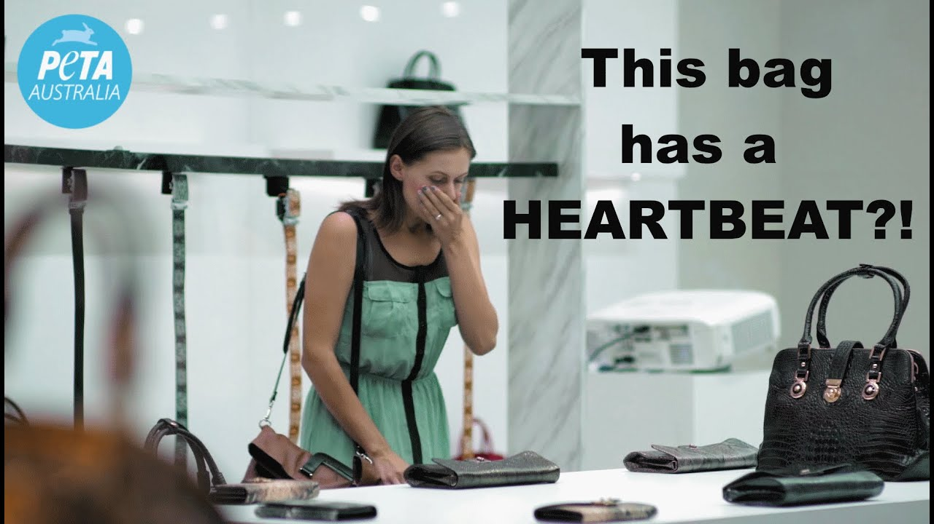
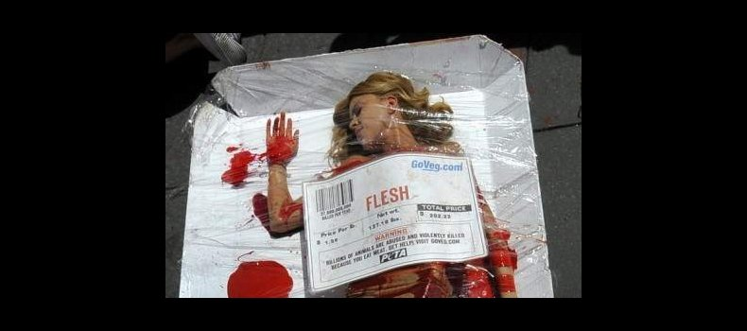
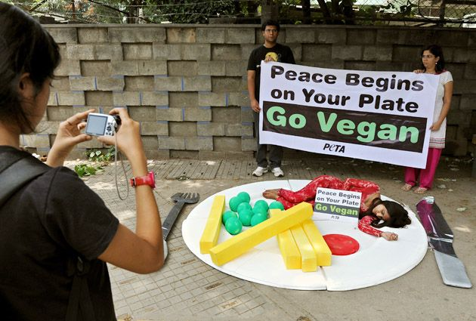
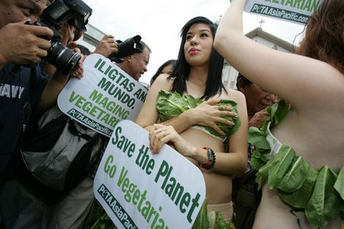
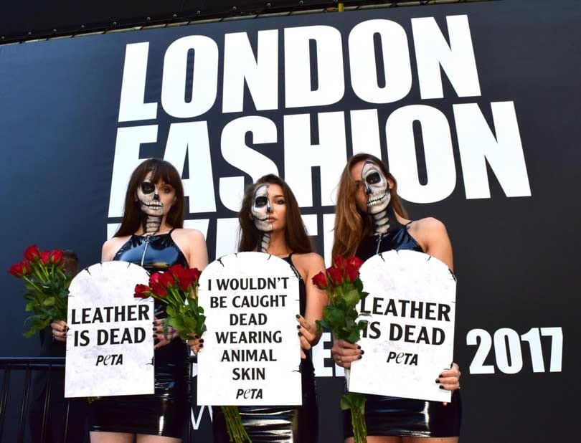
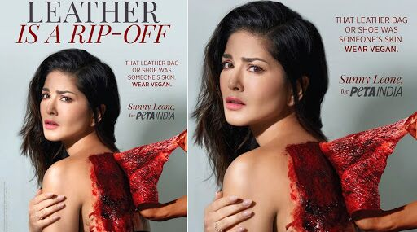

Haunted House of Real/True Horrors

Entrance: Did you know question cards & lift up question cards they can look at while waiting in line.
Have a flip up question/answer signs that fit into each of the themes in the haunted house. This way the guest will have an idea of what they are looking at/experiencing in the haunted house.
Interactive signs leading up to the entrance of the haunted house: (calculate results and share/compare with friends & family)
Plastic pollution facts & barcode scanner to plastic calculator
Plastic Calculator: https://www.earthday.org/plastic-pollution-calculator-2/
Climate change facts & barcode scanner for ecological footprint calculator
Ecological Footprint Calculator: https://www.footprintcalculator.org/

(optional) Al Gore masked character opening up the entrance to the haunted house

Haunted House Structure -
Need: Large black butcher paper or black curtains, white PVC pipe
Farm theme
Cows
Smell cow farts /step in cow manure (dirt?)
Fracking
Earthquakes (ground starts shaking)
GMO Corn Maze
Scarecrows/crows/ mutated (scary) corn-people
Need ---
Smelly cow machine (?)/ cow manure (dirt) on the ground/ cow cut outs/ corn stalks/ shaking ground machine/ scarecrows/

Under the Sea/Pacific Islands theme
Sea Level Rise
Water rising – actual water pumps in children’s blow up pool (optional)
*Note if you do decide to do this I recommend telling your visitors to wear boots on the flyer you can say “please bring or wear boots to wear in the haunted house because we are “in too deep”.
Plastic Pollution
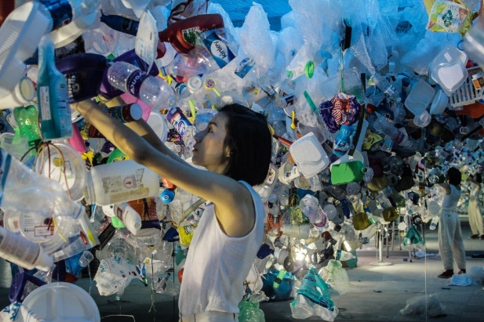
Maze of plastic with plastic hanging down (“dead ends” are the nets (caught fish in the nets))
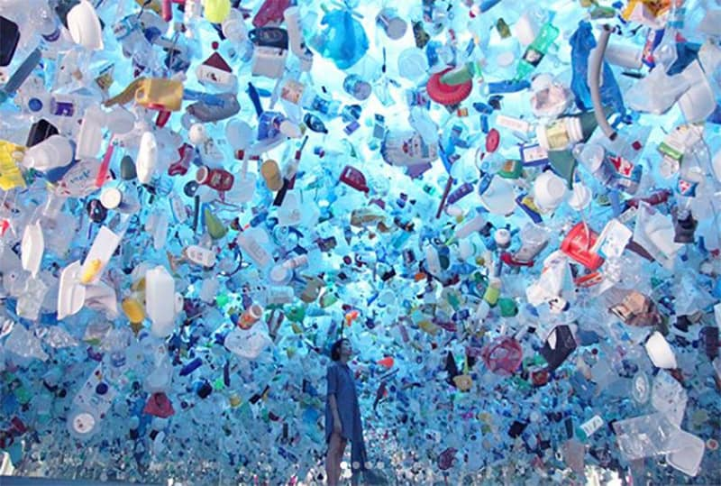

https://blueocean.net/immersive-installations-the-art-of-shifting-our-environmental-consciousness/
http://www.messymsxi.com/about/
Coral Reef Dying
Fog/ steam
Need ---
Coral/ plastic bags hanging/ hooks/ plastic water bottles hanging/ large nets/ tires on the ground/ hanging plastic toys/ water/ large tub (rising and falling water effect)/ projector
Projector on the floor and on the walls --- island shrinking (on the floor), glaciers melting (on surrounding walls), water rising (on surrounding walls)

Jungle theme
Palm Oil
Orangutan arm coming out of wrappers/ orangutan and bulldozer sound/ fire
Poaching
Deforestation
Chainsaw guy & bulldozer
Need ---
Fake trees and greenery/ chainsaw/ bulldozer (paper mache or golf cart)/ orangutans/ bulldozer sound effects/ fire in the forest/ heater/ fog machine/ vines hanging down/ sound machine (forest noises/bird noises)
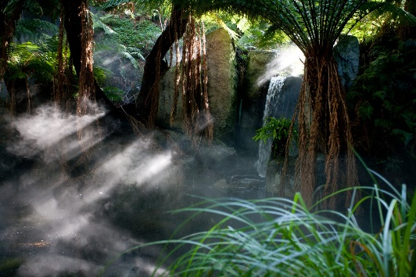

Butcher theme
Butcher
Hanging animal parts
Hanging pig upside down and slit throat with blood coming out
Burgers – McDonalds clown
Branding
Person on a BBQ
People in pig masks
Need ---
Burgers/ large fake pig/ fake animal meat hanging/ hanging hooks/ butcher knife & machete/ fake blood/ plastic tarp/ pig noise sound effects/ butcher gloves and black apron suit/ blood over the burgers/ McDonalds clown costume (bloody)/ fake blood/ branding/ red lights/ pig head masks

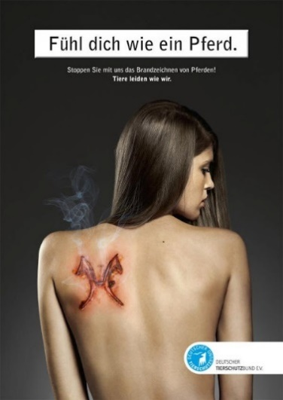

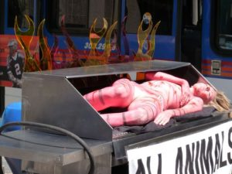

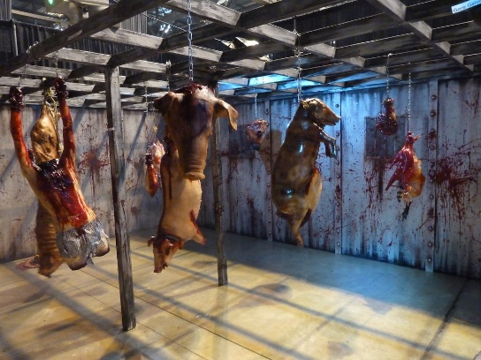
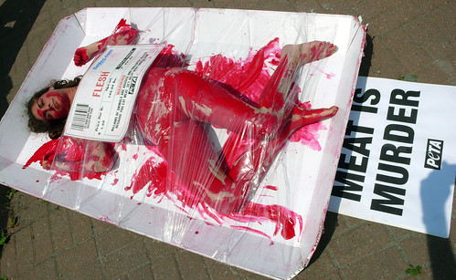

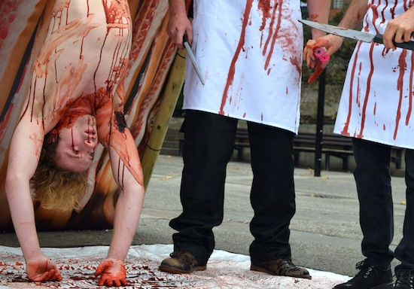

Mad Scientist theme
Testing On Animals
Monkeys on lab table and in cages
Rats and wires
Mad scientist character
Need ---
Lab coat & glasses & gloves/ monkey/ rats/ wires/ animals in cages/ metal table/ plyers/ dental tools

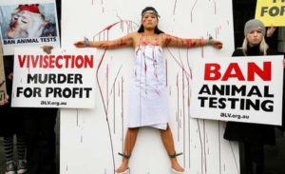
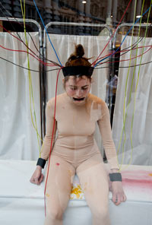
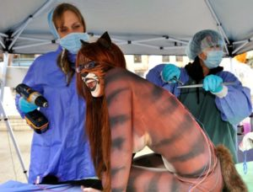

LUSH COSMETICS – ANTI-VIVISECTION DEMO

Clothing Store or Room theme
Fast Fashion
Hanging clothing racks people had to go through – blood on the clothing
Store Salespeople saying “buy this” “buy this”
Person at sewing matching with mouth stitched (silenced) sewing clothing on runway “model”
Fires in Bangladesh
People buried under clothing
Need --- sewing machine/ clothing racks/ clothing hangers/ thrifted clothing/ fake blood/ bedroom scene (bed and side table)

City theme
Air Pollution
Smog/steam as air pollution
Go through maze get down and move
Factories
Coal mining & coal miners
People walking around with gasmasks and Hazmat suites
Need ----
Fog machine/ building scenery (made of cardboard boxes)/ coal mining scene / fracking well/ Gas masks & Hazmat suites

Leather & Fur theme
Cows being skinned (leather)
Animals being skinned
Foxes in cages
Skinned animals laying on the ground
Actors laying with blood and fur coats saying “help me”
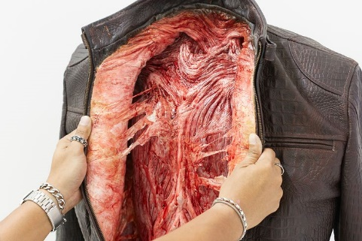
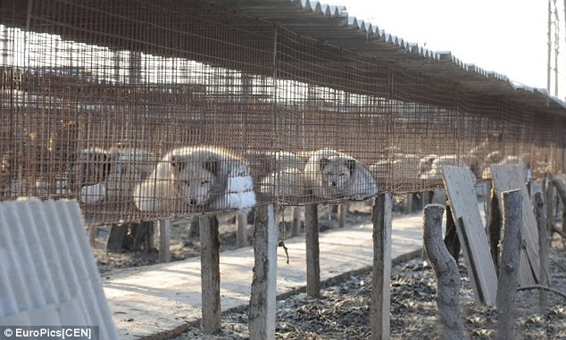
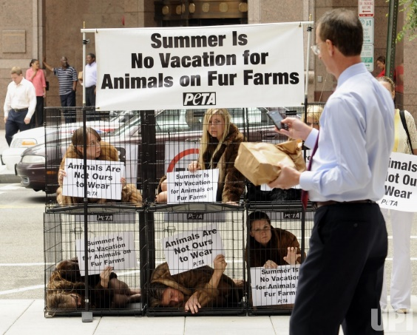
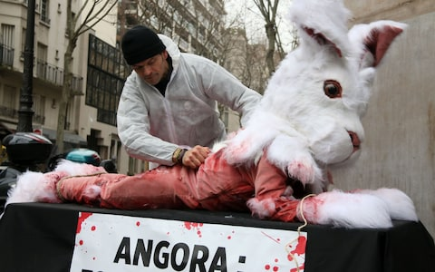
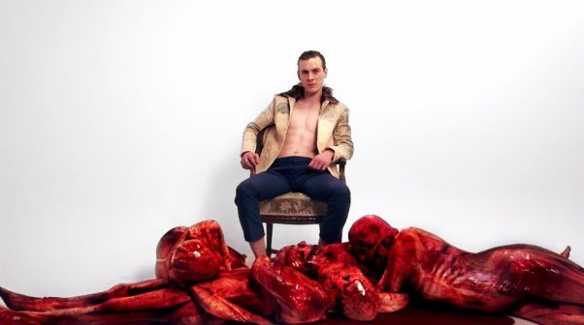
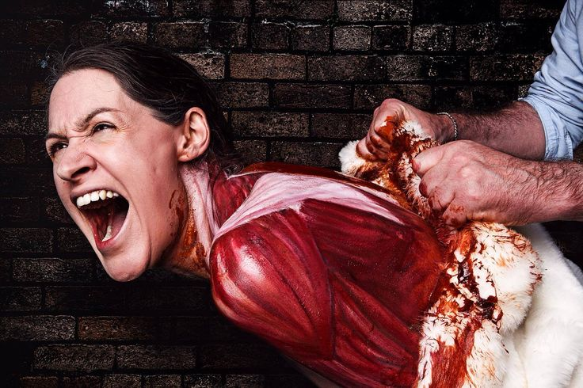
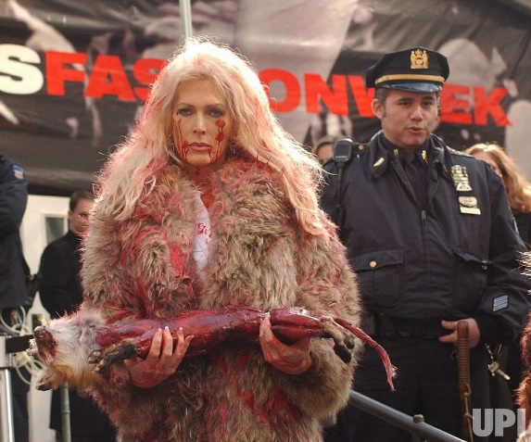
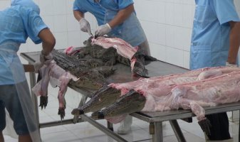
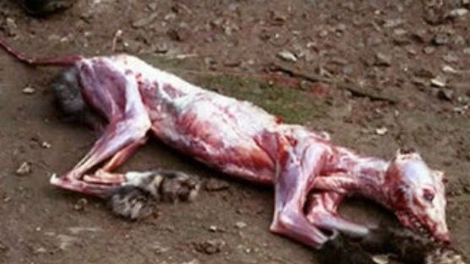
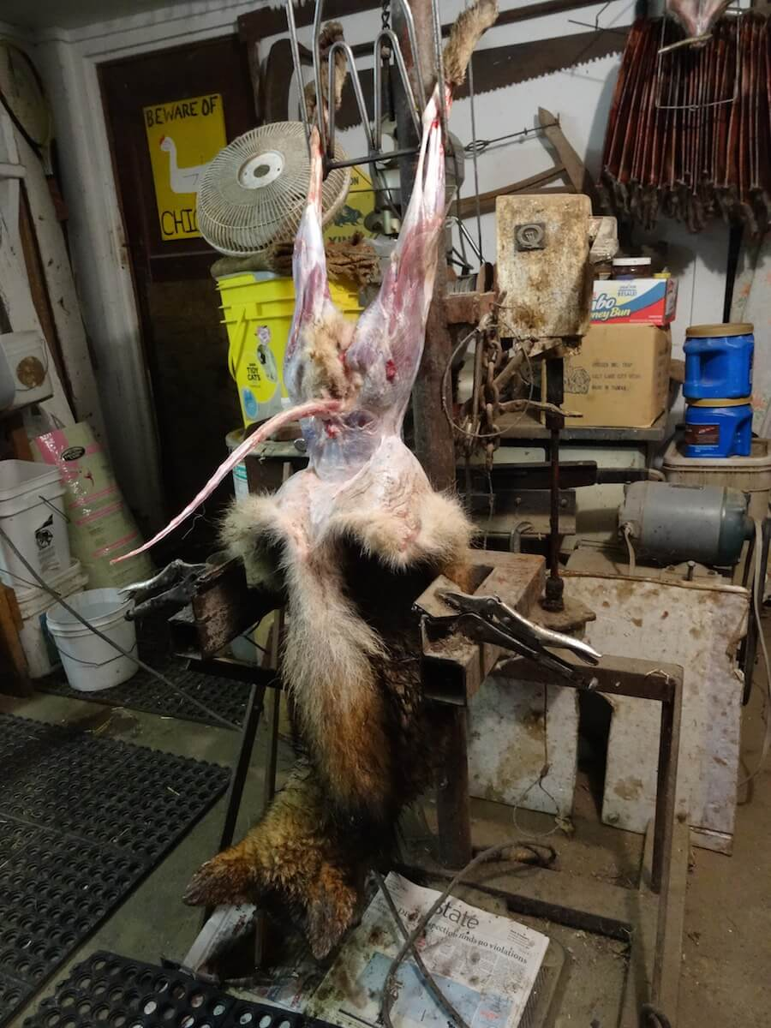
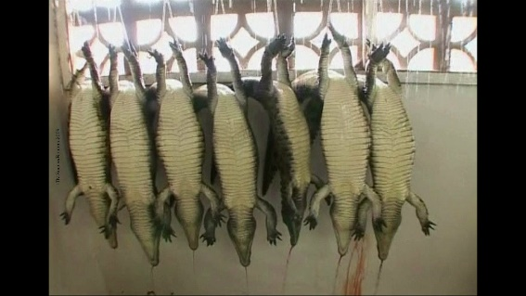

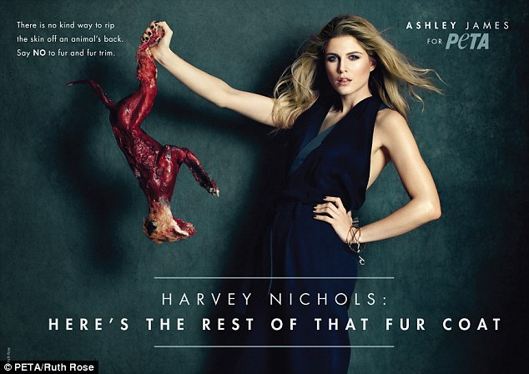

At the End:
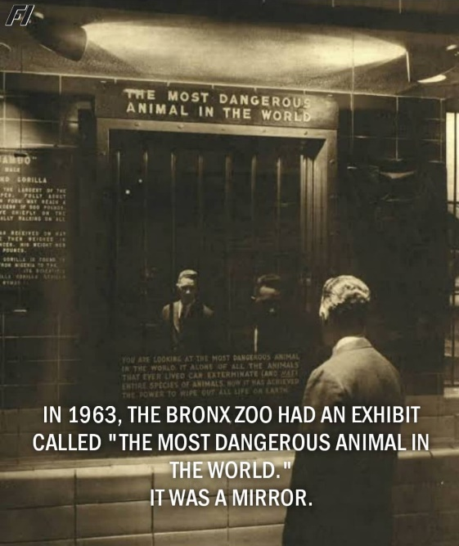
At the end of the haunted house have a section of mirrors all around them with the words “You are looking at the most dangerous animal in the world.”
How to make it happen!
You will need volunteers for set-up and acting. A great way to attain volunteers is by reaching out to local non-profits who care about the cause (climate change/animal rights).
Each non-profit organization can be in charge of a section:
PETA – Testing on Animals & Costume Contest
Sunrise Movement – Air Pollution
Citizens Climate Lobby
Climate Reality Project Chapter – farm theme
Extinction Rebellion – jungle theme
350 – under the sea
Anonymous for the Voiceless – Butcher

At the end:
You horrified yet? Well here’s what you can do!
Have tables for all the nonprofit organizations that contributed to the making of the “Fright for Future” event to answer questions and for the visitors to get involved in their causes!
Give them resources of ways the visitors can help! Direct them to Activist Attitude website to learn more!

